**12. OAUTH2 and OPENID connect**

what are the most common problems that this OAuth2 framework

is trying to solve inside the industry.

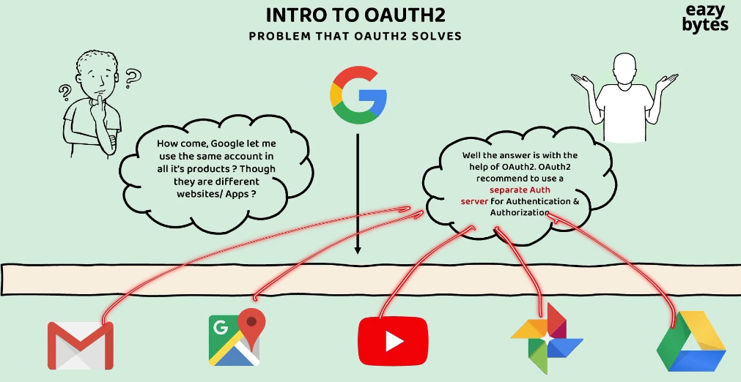

We all use this various Google products. Google has primarily Gmail as a product.

They also have Google Maps, YouTube, Google Photo, Google Drive.

So similarly, there are many other applications which are developed and maintained by Google or Alphabet.

All these applications of Google, they have their own separate code base.

All these web applications are mobile applications. They're going to be deployed

in different, different servers. But have you anytime wondered how all these Google products, they allow the same credentials as an input?

We as an end user, whenever we want to use any Google product, we need to create our own account with the help of Gmail. So the same Gmail credentials you can use

to authenticate in all the remaining applications.

For example, if I want to use YouTube to see the videos or to upload some videos,

I can log in into these YouTube mobile application or web application with the Gmail credentials that I have created previously. The same applies for the remaining Google products.

So how this is possible is, behind the scenes, Google as an organization,

it is following the OAuth2 standard or OAuth2 framework.

So whenever someone is following the OAuth2, it is going to recommend them

to use a separate authorization server which is responsible for storing the end user credentials, and the same Auth server is also responsible for end user authentication and authorization.

So initially, when an end user register into the Gmail account, a separate Auth server

will handle the registration process and will store the end user credentials.

The same Auth server will be used by all the applications inside Google

to authenticate the user and to perform authorization of the end user.

This way, we as an end users of Google products, we don't have to create

different, different accounts in different products and we don't have to maintain different credentials for different products of Google.

So the responsibility of this Auth server is, it is going to perform the authentication of the end user and it is going to issue the tokens during the login operation.

The same token can be used with the other applications as well.

For example, inside one of my browser tab, think like, I have logged in into my Gmail account. With the help of Auth server, I'm going to get an token. Now, this token will be saved somewhere inside my browser. Maybe after a few hours or maybe after few days if I try to open one of the different product of Google like Maps or YouTube or Photos or Drive, it is not going to ask me the credentials again, it is simply going to use the same token that is available inside my browser.

And with this token, the authentication and authorization is going to happen

without me entering any credentials.

So this is possible because all these web applications are mobile applications. They're pointing to the same Auth server which issued the token originally.

So this is a very first major problem that OAuth2 is solving inside the industry.

Always OAuth2 framework is going to recommend to maintain separate authentication server inside an organization.

Let's try to take one more scenario and try to understand what are the advantages that we get if you try to maintain a separate Auth server inside an organization.

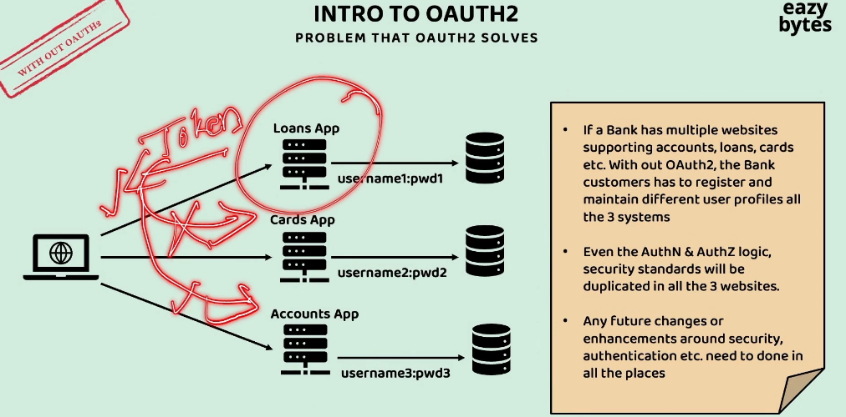

Think like, there is a bank application which has multiple websites supporting accounts, loans, and cards.

If these bank application, if they're not following the OAuth2 framework,

then the bank customers, they have to register and maintain different user profiles

in all the three systems.

Inside each of these applications, if they have their own authentication and authorization logic, then the end user will end up creating different credentials for different applications, and all these credentials are going to be stored in different storage systems.

So here, clearly, these people, they're not following the OAuth2 framework

inside the bank organization. With these, we are going to have multiple challenges.

The very first challenge or drawback is the security-related logic

like authentication and authorization, it is getting duplicated in multiple places.

So in future, if there is a requirement change around the authentication and authorization, the same has to be done in all these three places.

The next challenge is, think like, this loan application has issued a token

during the login process to the client application.

So the same token is not going to make any sense to the other applications.

That's why they're going to reject that token. They always accept their own credentials, and they're going to issue their own tokens during the authentication and authorization process.

Always try to separate your security-related logic into an Auth server

so that your individual applications, they are going to simply have the logic

related to the business logic.

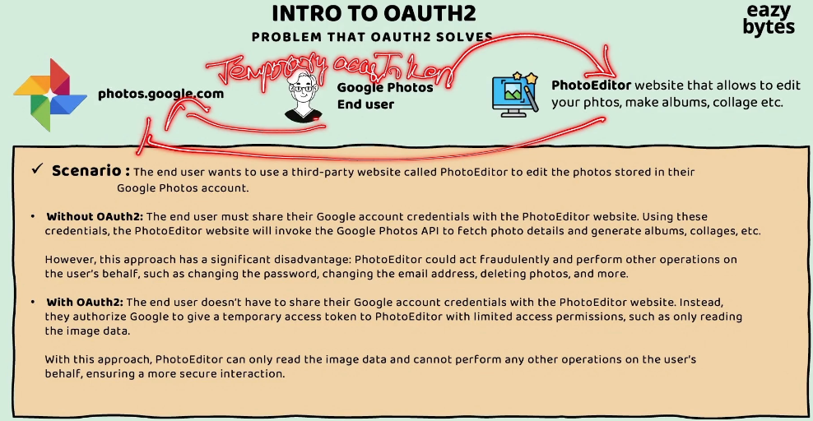

The next common problem that OAuth2 framework try to solve inside the industry is,

Delegated Authentication or Authorization.

Think like you are an end user who maintain all your photos inside the Google Photos, and there is a third-party app with the name PhotoEditor.

So this PhotoEditor third-party app, it is going to allow you to edit your photos

with the help of artificial intelligence, and it is also going to help you

to create albums out of your photos. It is also going to help you to create collage of your photos.

Since this third-party app is providing all these features, you decided to use this third-party app.

So let's try to imagine this scenario

without OAuth2 and with OAuth2.

In a very common basic scenario, what you're going to do?

You're going to download the photo from your Google Photo.

The same you're going to upload into the PhotoEditor for performing some edits.

So the same process you need to do for all the photos.

So this is going to be very cumbersome process.

So to make your life easy, PhotoEditor, they supports integration with the Google Photos.

So this integration with the OAuth2, it is going to be supported in two different styles.

One is without OAuth2 and the other one is with OAuth2 framework.

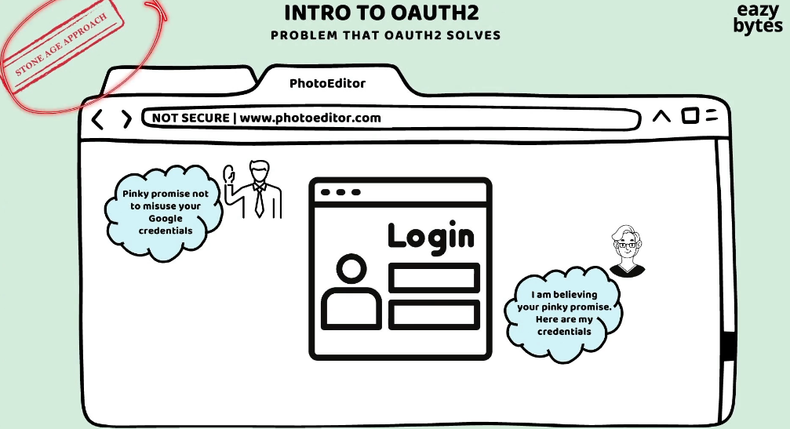

So let's try to understand what is going to happen inside the without OAuth2 scenario.

In this scenario, the PhotoEditor third-party app, it is going to ask the end user

to provide his Google Photo credentials.

Though sharing the Google credentials directly to this website is a risky option,

still this end user want to share his credentials because he liked the features

provided by this website a lot. They're going to use the credentials of this end user,

and they're going to read the photos from the Google Photos website for editing.

So this used to be a stone age approach where people used to follow these

before OAuth2 introduced.

So whatever we discussed, this is a very happy scenario.

But there is a significant disadvantage in this approach, which is, the PhotoEditor application, they may do some fraudulent activities by performing other operations on user's behalf. They can change the password or they can change the email address because they know the actual credentials of the end user.

Now, let's try to imagine the same scenario with the OAuth2.

So with OAuth2 what is going to happen is, the end user will not share his Google credentials to the third-party application. Instead, he's going to let Google Photos

to issue an temporary access token. Using this temporary access token, the PhotoEditor app, they can only read the photos from the end user Google Photos account. With the access token that is issued by the Google Photos

on behalf of the end user, it is only useful to read the images or to load the images.

Apart from reading, any other operations will straight away rejected by the Google photos because the access token issued to the third-party app

does not have enough privileges.

So whenever we are using OAuth2, what is happening?

The end user delegating the authentication and authorization

to the PhotoEditor app to read his photos from the Google Photos.

And whenever the end user feel like he no more needed the services of this website,

he can easily revoke the permission that he has initially issued to this website

by logging into the Google account.

Introduction to OAUTH2

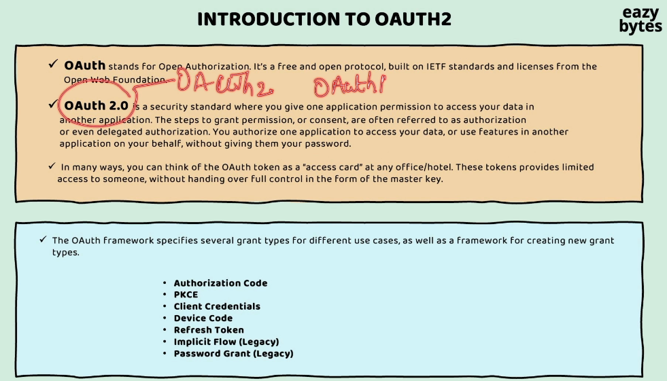

OAuth 2 is a free and open source protocol that is built by the open source community. When I say OAuth 2, it is a standard, or it is a protocol,

or it is a specification that every organization has to follow

whenever they're trying to implement authentication

and authorization inside their organization.

Whenever an access token is issued to a client application or a third-party application, with the help of that access token, they should be able to read that data of the end user. So with the help of this access token, they should be able to perform only a limited functionality.

You need to follow one of the grant types that are supported by the OAuth 2 framework.

For example, if an **end user is involved during the authentication and authorization process, then we can use either of the Authorization Code or PKCE grant type flow**

**based upon the type of our application.**

If your application is built using the JavaScript frameworks, like, Angular, React, or mobile applications, in such scenarios, you need to use PKCE.

Otherwise, you can safely use Authorization Code.

The next grant type flow that we have here is Client Credentials.

So these Client Credentials, we need to use whenever two different backend applications or two different APIs, they're trying to communicate with each other.

So in these scenarios, the end user is not involved.

whenever two different devices or IoT applications, if they're trying to communicate with each other, we need to use the Device Code grant type flow.

Similarly, there is a Refresh Token grant type flow that can be used in the scenarios whenever an access token is expired and if you're looking to get a new access token.

Implicit flow is very similar to the Authorization Code grant type flow, but it's a older version of Authorization Code grant type flow, which has some drawbacks.

That's why this Implicit flow is deprecated right now.

This Password grant type flow is also a flavor of Authorization Code grant type flow,

and this is also deprecated due to its drawbacks.

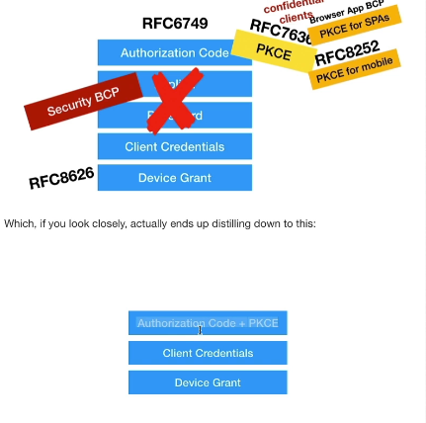

As part of OAuth 2.1, the open source community, they're trying to reduce the number of grant type flows to Authorization Code plus PKCE and Client Credentials and Device grant.

With that, we are only going to have three grant type flows in the future when this 2.1 is officially released.

So they are recommending to use the Authorization Code with PKCE instead of using them separately.

OAuth2 terminologies or jargons

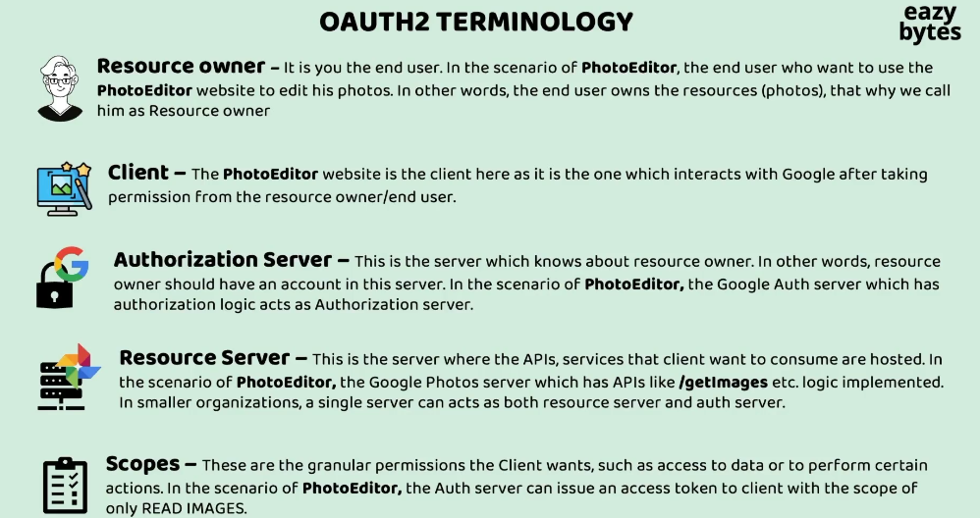

So in the scenario of PhotoEditor, the PhotoEditor application,

it is going to invoke the /getimages API, which is exposed by the Google Photos resource server.

So when client application asks for the resources, obviously, the resource server will expect an access token before providing the response.

So how to get the access token, the client first has to reach out to the authorization server to get the access token. Once the access token is received, using the same access token, it can reach out to the Resource Server to fetch the resources.

In smaller organizations, there is a good possibility that a single server can act

as both resource server and auth server.

**So just like how we have authorities and roles concept inside the Spring Security framework, very similarly, inside the OAuth 2 standards, we call them with the name or with the jargon scopes.**

Demo of OAuth2 Sample flow

Apart from this regular process of account creation or account login, this slack website is also supporting social login.

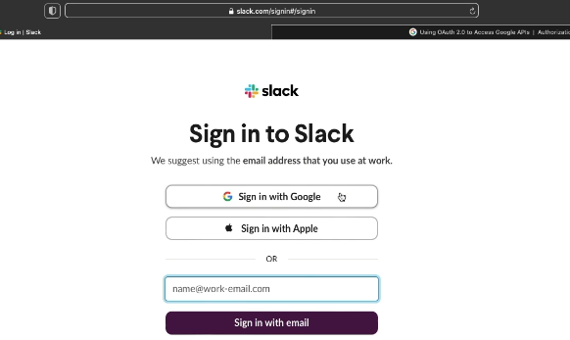

So what is a social login?

Social login is a process where we can quickly sign in into a third party application by entering our social credentials from Google or Apple or Facebook, Twitter, GitHub, LinkedIn. So since all these Google, Apple, or any other social organizations, they have their own authorization servers.

So here, what Slack is doing is it is giving a flexibility to the end user if you are in a hurry and not able to create your own account from scratch by entering your first name, last name, email, and date of birth, gender, all other details, you can simply use the social login option.

So whenever we use social login option, what is going to happen?

My profile details which are stored inside the Google auth server, they are going to be fetched and given to the Slack.

So Slack behind the scenes, by taking my profile details from Google or Apple,

it is going to create an account for me very quickly.

Initially, OAuth 2.0 is invented for delegated authorization where we can delegate authorization to your third party app to read our own data in some other application.

But inside the industry, people became super smart, and they started using for authentication as well.

So here, the Slack website, they're trying to use the OAuth 2.0 framework for authentication. In future, whenever I want to log in into this application,

I just have to use the same option, which is sign in with Google.

And with that, my authentication is going to be super quick.

Here, Slack has a integration with the Google Auth server.

Behind the scenes, what Slack is going to do is before it try to enable this button on this website, they will approach to the Google team and express their interest in using social login in the Slack website, and Google team, what they're going to say, they'll say, "Um fine, you just have to create your own details inside my Auth server so that the integration between Auth server and Slack is going to work seamlessly."

So if you go to the official documentation of OAuth 2.0 from Google inside this website, you'll be able to see what are the steps that any organization has to follow if they want to use Google as an auth server inside their websites.

So first, the organization like Slack, they have to register themselves to get the client ID and their client secret.

**So these credentials are different from the end user credentials.**

These client ID and client secret, they're going to be used by the Google Auth server

to identify which client application is trying to invoke the authentication or authorization process. Here, the client is going to be Slack, so Sack is going to get its own ID and secret, which it has to use while it is trying to invoke the authentication process here.

So here, if I click on the sign in with the Google, it is going to redirect me to the Google login page. You can see the domain, accounts.google.com,

and here there is a client ID which, so this client ID represents Slack.

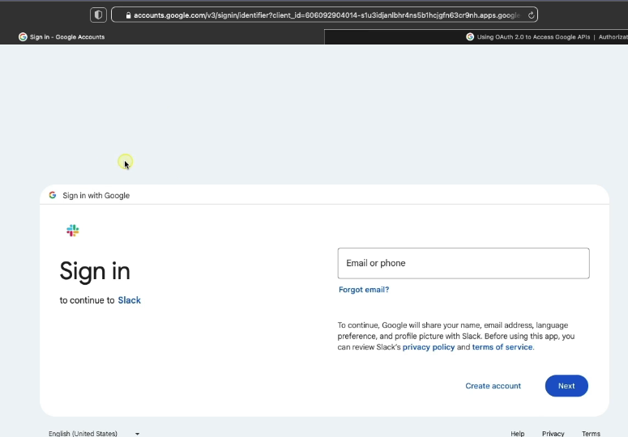

So here, I can enter my Gmail username and password. As soon as I click Next,

you'll be able to see I'm getting a consent page that is being asked by Google, saying that by continuing Google will share my name, email address, language preference, profile picture with the Slack.

So here, as soon as I click continue, behind the scenes an access token will be issued by Auth server. The same will be sent back to the Slack,

and Slack will land me onto their website.

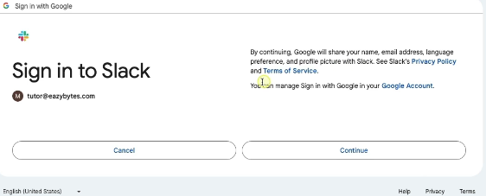

But as a software developer, we will not see these kind of social logins inside real applications.

For example, if you are building a web application or mobile application for a bank

or for an insurance company, there is a very good chance that they may not use the social login option.

Instead, they are going to set up their own auth server using which they'll be able to issue the access tokens to the third party applications or to the applications belonging to the same organization.

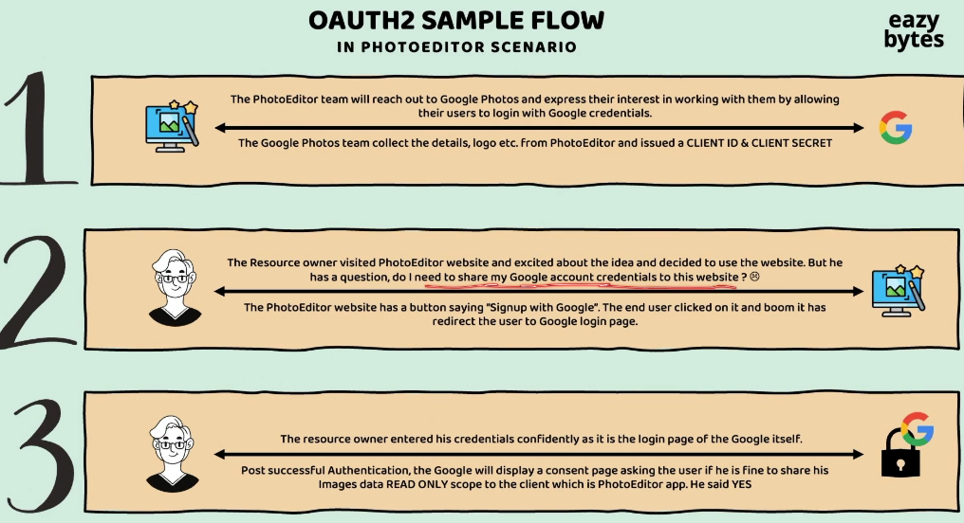

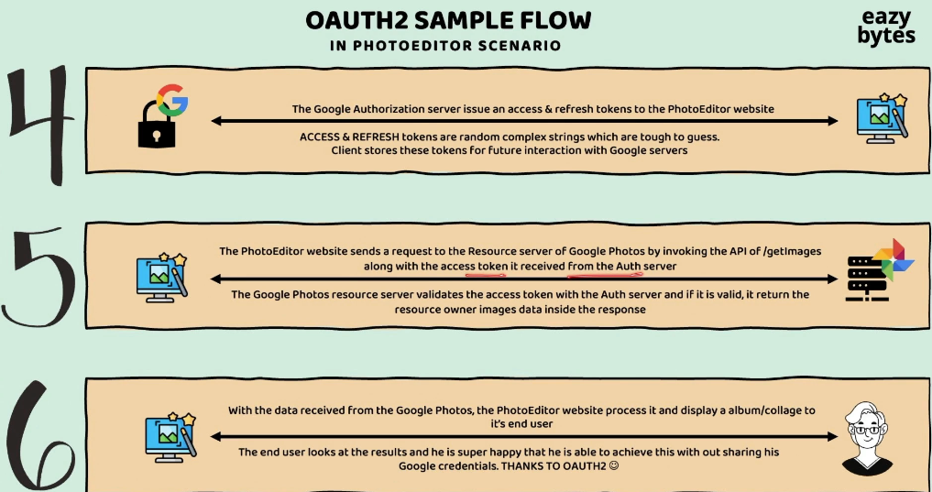

 Deep dive on Authorization code grant type flow in OAUTH2

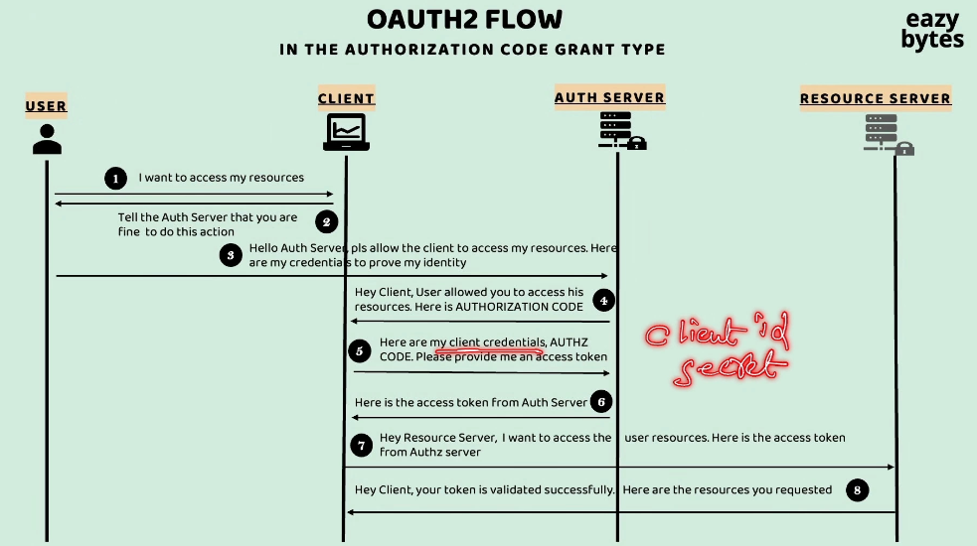

There'll be four different components or parties involved. The very first party is end user. End user, in other words, we can also call as Resource Owner.

The second component is Client application followed by Auth Server, followed by Resource Server. So this Client application and Resource Server can belong to different organizations, or they can belong to the same organization.

Regardless of their relationship, this authorization code grant type flow,

it's going to work very similarly.

Steps;

Whenever an end user requested a resource to a Client application.

The Client application will redirect the end user to the login page of the Auth Server.

The end user is going to prove his identity by entering username and password

inside the login page of the Auth Server.

Once credentials are validated, the Auth Server will return an authorization code. So this is not an access token. This is a temporary code that is going to be issued by the Auth Server to the client application.

So as part of the step three, the end user proved his identity. As a next step 5,

the client also has to prove its identity by sharing its client secret.

Along with the client credentials (client_id and client_secret), it should also send the same Authorization Code that it has received as part of step four.

So by providing all these details, it is going to request the auth server to issue an access token.

If all the details are valid, as part of the step six, the Auth Server, it is going to issue an access token to the client application.

So now using this access token, client is going to call the Resource Server

saying that I want to access so-and-so end user resources and this is the access token for your reference.

The Resource Server is going to validate the access token is valid or not. If the access token is valid, it is going to send the actual resources requested

by the client application as a response.

How my Resource Server is going to validate the access token issued by the Auth Server?

Because they are two different components, and I don't see any communication

between these two components.

So this can be a question.

If you can recall our JWT tokens discussion. Inside the JWT tokens, there is a digital signature concept. Using the digital signature concept, one can validate if the token is valid or not by themself without the need of reaching out to the token-issuing component. The same is going to happen here as well.

The Resource Server, it don't have to talk with the Auth Server.

Since the access token also is going to come in a JWT format, it is going to validate it very quickly behind the scenes without interacting with the Auth Server.

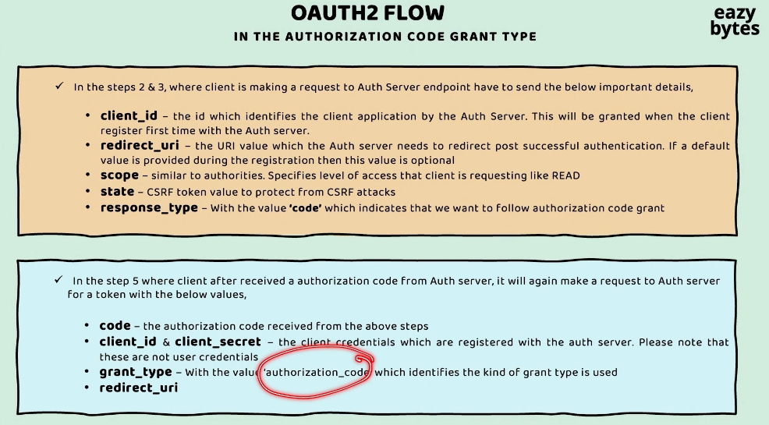

how my Auth Server will know to which page of the client application it has to land

during the Authorization Code flow and during the access token flow?

As part of the step two and three where the end user identity is going to be verified by the Auth Server.

Client application send the client_id only, but not the client_secret. So using this client_id, the Auth Server can identify the details of the client application,

and the same details, it is going to show you on the login page of the auth server saying that so-and-so client is trying to access your resources.

Are you fine with that?

So this kind of consent the Auth Server is going to show based upon this client_id

that it received as part of step two and three.

Apart from client_id, the client application, it is also going to send other details like redirect_uri, scope, state, and response_type.

The purpose of redirect_uri is very simple. Inside these request parameter only,

the client application is going to mention what is the URI value that the Auth Server needs to redirect post to end user's successful authentication.

And inside the scope, the client application is also going to mention what are the authorities or what are the level of access that the client is looking inside the Resource Server.

For example, if the client is looking for the READ **scope**, the same it is going to be mentioned inside the scope details.

So these scope details will also be displayed to the end user inside the login page

saying that so-and-so client is trying to request so-and-so scope details, are you fine?

After the scope we have state request parameter. So inside the state request parameter, we are going to send a randomly generated **CSRF** token value.

So this is to protect from the CSRF attacks.

If the end user identity is verified, the client application is expecting an Authorization Code. That's why we need to mention these **code** as a value inside the response_type during the step two and three.

So in step four, we know what is going to happen.

The Auth Server, it is going to redirect the response to the redirect_uri with the Authorization Code. Once the Authorization Code is received by the client application, what it is going to do is, as part of the step five, it is going to prove its own identity.

So that's why this time inside the request, it is going to send both the client_id and client_secret. Along with these client_id and client_secret, it is going to send the same Authorization Code value that it has received as part of step four.

And this time, it should also mention grant_type inside the request.

The grant**_**type should be Authorization Code, because we are expecting

an access token belongs to an end user.

So that's why we need to mention this valid value, which is Authorization Code.

Apart from grant_type, it is also going to send the redirect_uri, which is going to have the URI details that Auth Server can be used to redirect the response after issuing an access token.

So whatever CSRF token value that we have mentioned initially under this state,

it is going to play a very important role to avoid the CSRF attacks.

So based upon our discussion, you may have a question, which is, why in the Authorization Code grant type flow, client is making requests two times?

The very first time it is trying to make a request to get the Authorization Code,

followed by another request to get an access token.

So this can be your question.

To answer your question, this grant type flow is designed this way for better security.

So in the very first step, the authorization server will make sure only the end user directly interacted with it by asking the end user credentials inside the login page.

Once the end user identity is verified, it can't issue directly the access token,

because the Auth Server has to verify the client identity as well.

That's why it is going to make one more request where it is going to expect client_secret as well. So if the client_id, client_secret, and Authorization Code, all of them are correct, then the Auth Server is going to issue an access token.

To answer your question in simple words, we can say inside the authorization code grant type flow, the client application has to call two times for better security reasons.

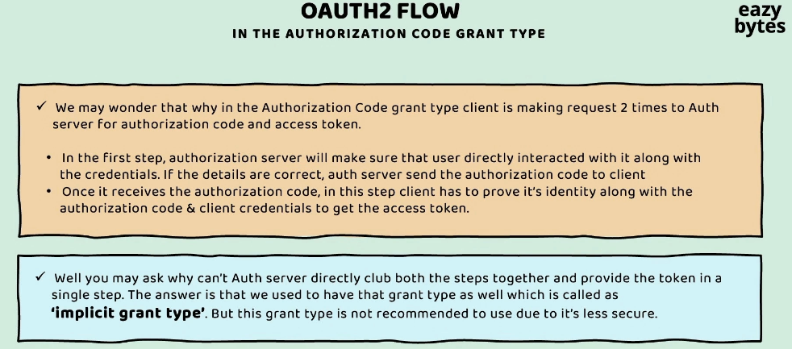

We have a grant type flow with the name implicit grant type.

As part of this implicit grant type, the client application, it is going to make only one request to the auth server, and within one request, it is going to get the access token directly.

There won't be any authorization code involved.

Inside a single step, the auth server is going to validate both end user identity and the client identity.

this grant type is deprecated right now due to its drawbacks since it is less secure.

Demo of Authorization code grant type flow in OAUTH2

OAuth is an organization acquired by okta recently. So both these OAuth and okta, they have commercial products using which organizations can build their own auth server by following the OAuth standards.

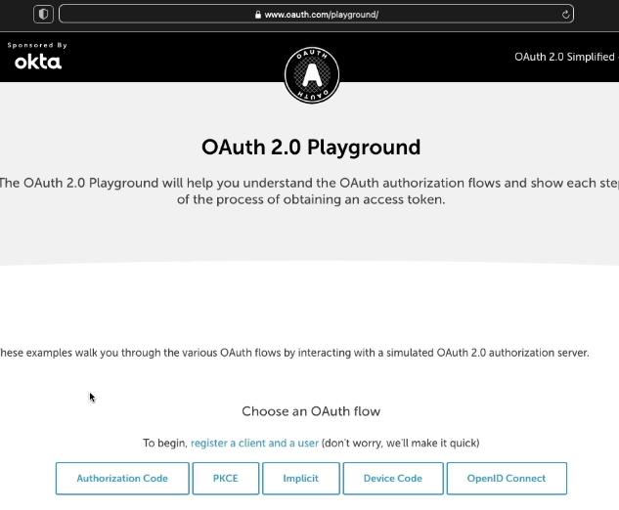

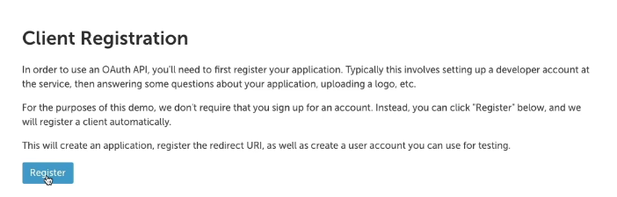

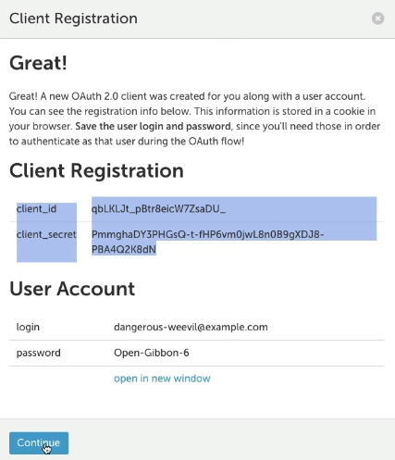 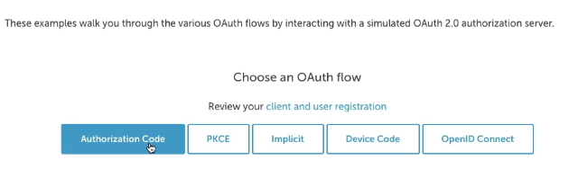

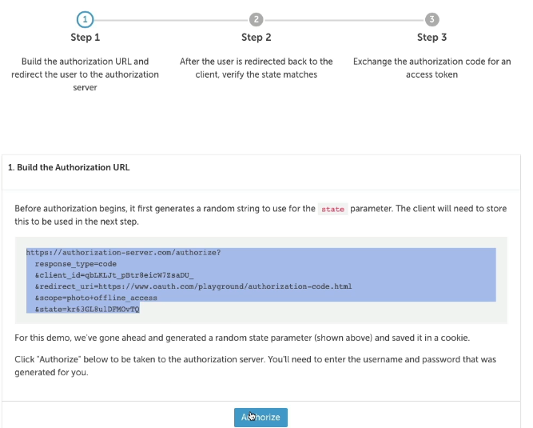

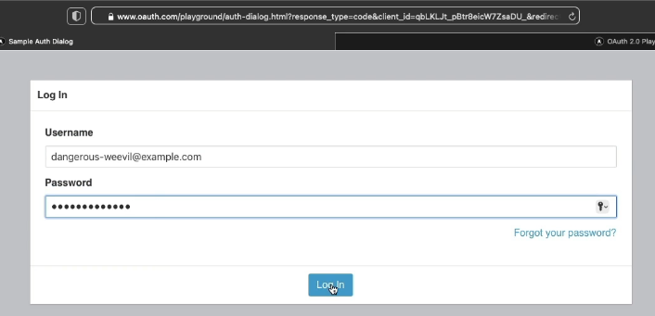

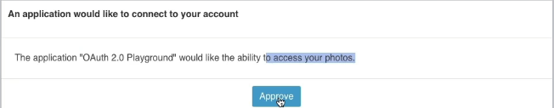

As soon as I click Approve, what is going to happen?

The auth server, it is going to issue the Authorization code.

So as part of the step two, the client application, it is going to make sure that the token value that it has received under the state is it the same as the initial value

that it has sent as part of the step one.

So this is going to give and confirmation to the client that the authorization server only send these code details but not any other hacker.

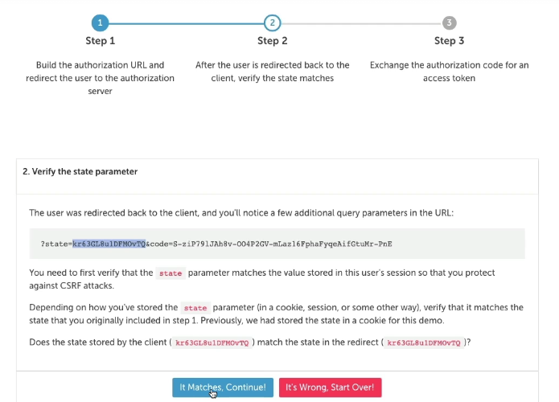

So if the state token value is same,

we need to click on this It Matches, Continue.

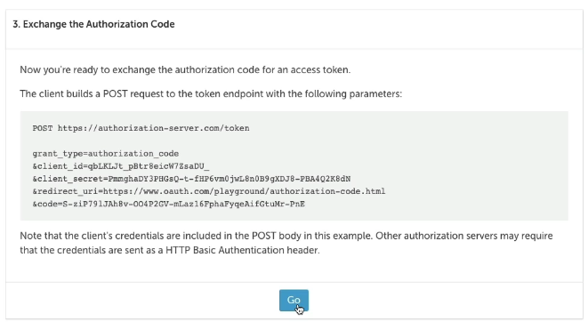

And inside the third step, the client application is going to send a request

to get an access token. Inside this third step, it is going to make a post request.

So previously, all the requests are get request.

As soon as I click on this Go button, behind the scenes the auth server, it is going to validate this client details, Authorization code.

If all of them are correct, it is going to issue the access token and redirect the end user to so and so redirect_uri.

As a response you'll be able to see I'm getting an access token.

And that refresh token and this access token, it is going to expire in so and so seconds.

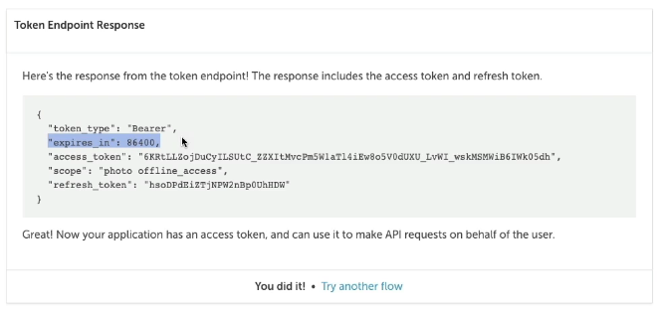

Deep dive & Demo of implicit grant flow in OAUTH2

this grant type flow, as of now, it is deprecated,

and soon, inside the 2.1 version, it is going to be completely removed.

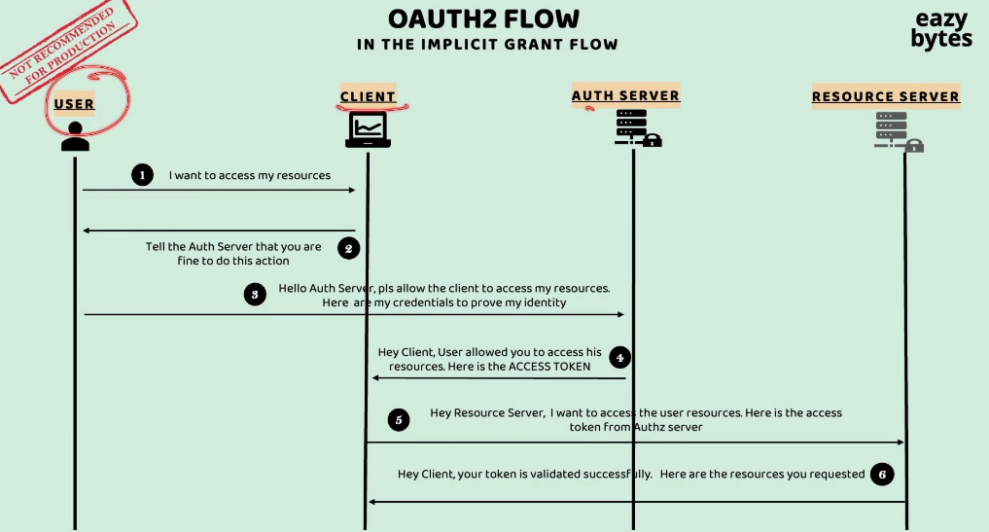

If the end user credentials are valid, as part of the step four response, the auth server, it is directly going to issue the access token.

There is no concept of Authorization Code here.

Directly, the access token is going to be issued by the Auth Server to the client application. So once the access token is issued, the client application, it is going to make a request to the Resource Server to access the User resource

by sharing the access token inside the request.

If you try to understand the primary reason around why this is deprecated

is it is trying to share the access token in a single step, and with this, there are certain drawbacks.

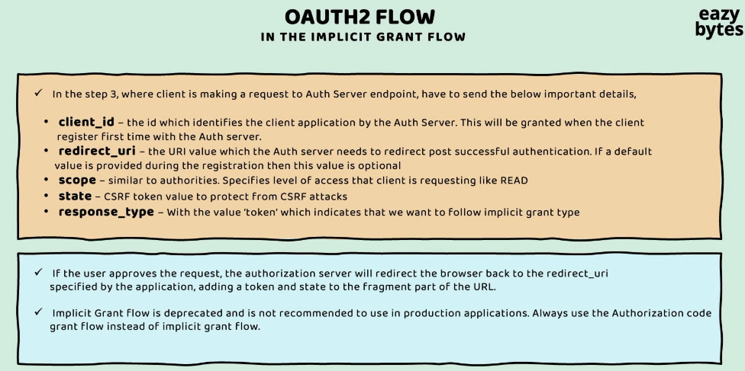

Let me try to explain what are those drawbacks.

Since inside the step three, the client is going to make a request to the auth server using the GET request. it is only going to send the client_id, redirect_url,

scope, state, and response_type. So the response_type is going to be token,

and you know what is the purpose of scope, state, redirect_url, and client_id.

Inside this flow, there won't be any Client_Secret involved,

so only the client_id is enough. The reason why client secret is not involved is,

since this is a GET request, inside the GET request, there is no meaning of sending the client secret. That's why this flow does not support client secret

as part of the step three request.

And with that what is going to happen?

Anyone who knows the client_id, they will be able to mimic as a client application with the auth server, and once the end user entered his credentials, they should be able to get the access token.

So since there is no way for the auth server inside this flow to validate the identity of the client application, this is marked as deprecated because hackers, they found too many ways to steal the access token inside this flow.

Apart from these drawback, the other serious drawback is when the auth server is trying to share the access token with the client application, the access token is going to be shared inside the request URL itself because, initially, the request went using GET, so to this GET, as a response, the auth server can only send using GET only since it is going to send the access token inside the GET URL itself, there's a very good chance that anyone who has access to your browser history, they'll be able to steal your access token.

Think of a scenario, one of the auth server is issuing an access token with an expiration of seven days.

In this scenario, you might have used the access token on day one and you left the computer. If some other user has access to your browser history, they'll be able to easily know what is the access token that auth server sent initially.

Using the same access token, there is a good chance that they may misuse it.

Demo

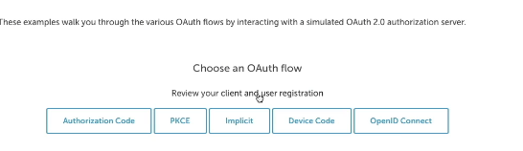

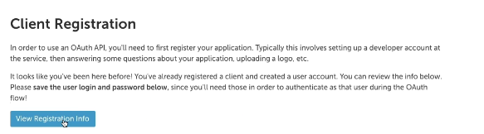

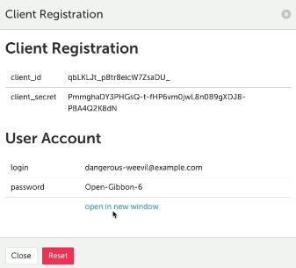 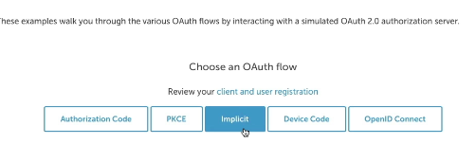

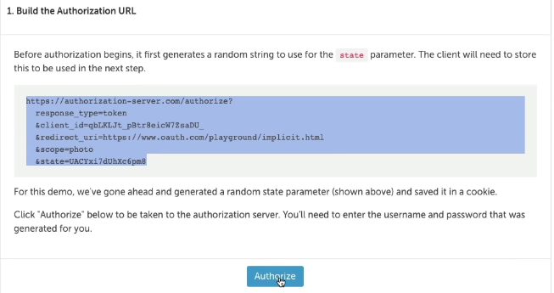

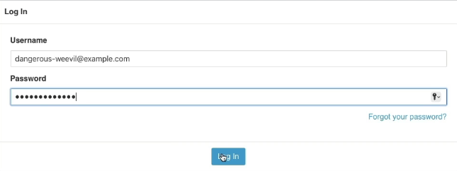 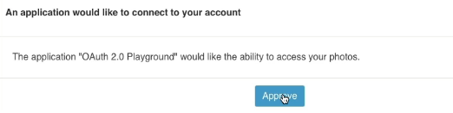

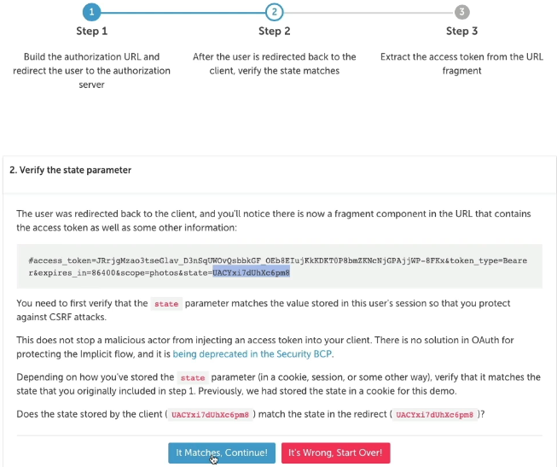

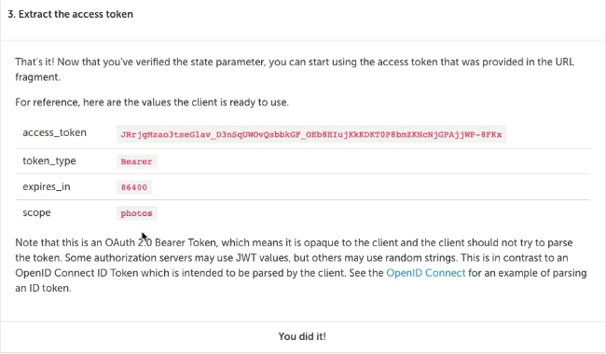

Deep dive & demo of Authorization code grant type with PKCE

So what is a full form of PKCE?

Proof Key for Code Exchange.

This is going to work very similar to authorization code grant type flow,

but it has some minor differences. In other words, we can call this PKCE

as another flavor of authorization code grant type flow.

I said as part of the step five, the client application, they have to share their client credentials. So as part of these client credentials, they need to pass their client_id and the client_secret.

But unfortunately, the client secret can't be saved by the public clients like JavaScript-based applications, single page applications which are built

based upon angular reactive framework mobile applications.

Because all the client code, it is going to be built with the help of plain JavaScript

and anyone can see the source code inside the browser or by downloading the mobile application installation file.

And with that, they'll be able to see the client secret very clearly.

That's why for public-facing clients, where they're going to build a code

with the help of JavaScript for such applications, instead of following the authorization code grant type flow, we can happily follow PKCE grant type flow.

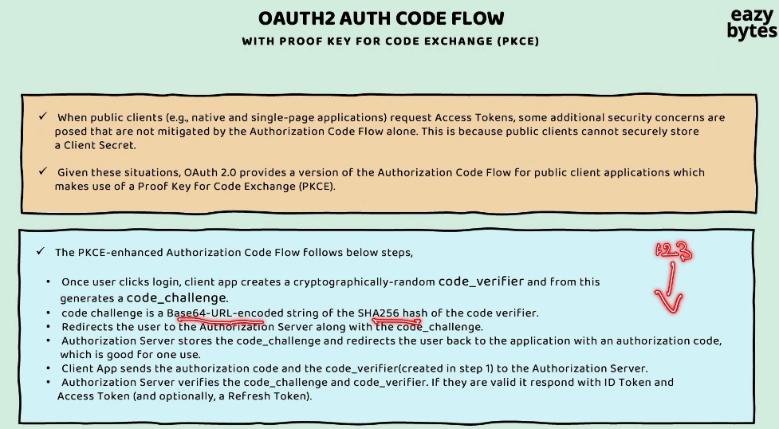

Let me explain you how PKCE is going to solve this problem for the public-facing clients.

Whenever an end user clicks on the login button or whenever he tried to initiate an operation inside the client application, then we know the client application,

it is going to redirect the end user to the Auth Server login page.

So during this redirection, behind the scenes the client application, is going to generate two different values.

**One is code_verifier and the other one is code_challenge.**

**So using this code verifier only, this code challenge is going to be derived.**

For example, if the code verifier value is 123, using this 123 only, the code challenge is going to be derived by applying the SHA256 hash function. And once the hashing function is completed, it is going to be Base64-URL-encoded.

So once that code verifier and code challenge is generated by the client application,

during the very first step where it is trying to redirect the end user to the login page

of the Auth Server, in this very first step, the client application, it is only going to share the code challenge with the Auth Server.

So inside the request parameters, along with the client ID, it is also send the code challenge. This code challenge is going to be saved by the Auth Server behind the scenes. So once the end user authentication is successful, we know the Auth Server is going to send back the response to the client application along with the **authorization code**.

**So now using this authorization code, the client application has to prove its identity.**

So how it is going to prove its identity is, this time while it is trying to request

for the access token, along with the **authorization code** that it has received, it is also going to send the **code verifier** that is generated initially in the very first step on the client side.

Using this code verifier, the Auth Server, it is going to apply the same hashing function on top of this code verifier, and with that whatever initial value

that it has received as part of code challenge, it has to be equally same;

otherwise the Auth Server is not going to issue the access token.

This way, Auth Server is making sure that whatever client application that initially initiates the request in the very first step, the same client application has to get the access token.

There should not be a scenario where in between someone trying to steal the authorization code and they're trying to get an access token with the help of authorization code.

**That is not going to be possible, because only the client application will have**

**the code verifier matching with the code challenge**.

So here you may have a question which is why code challenge is being shared first followed by code verifier at later point of time?

It's a great question, let's try to understand the same.

We know the code_challenge is a hash representation of code_verifier.

In the very first step, this code challenge or hash value is going to be shared to the Auth Server so that in between, if someone steals this code challenge it is not going to make any sense to them because using this code challenge, they cannot derive the code verifier because it's a hash value.

Only the client application which generates this code challenge, they will only know

this code verifier plain text value. That's why this code challenge is being shared

in the very first step, followed by code_verifier at a later point of time when client application is trying to get the access token.

So once all the validations are completed on the Auth Server, it is going to issue an access token, ID token, refresh token, based upon what is being requested by the client application.

This way, though there is no client credential involved inside the authentication flow,

the Auth Server will make sure that it is issuing an access token to only the original client application who initiates the authentication flow.

So let's try to see all the steps by taking a flow.

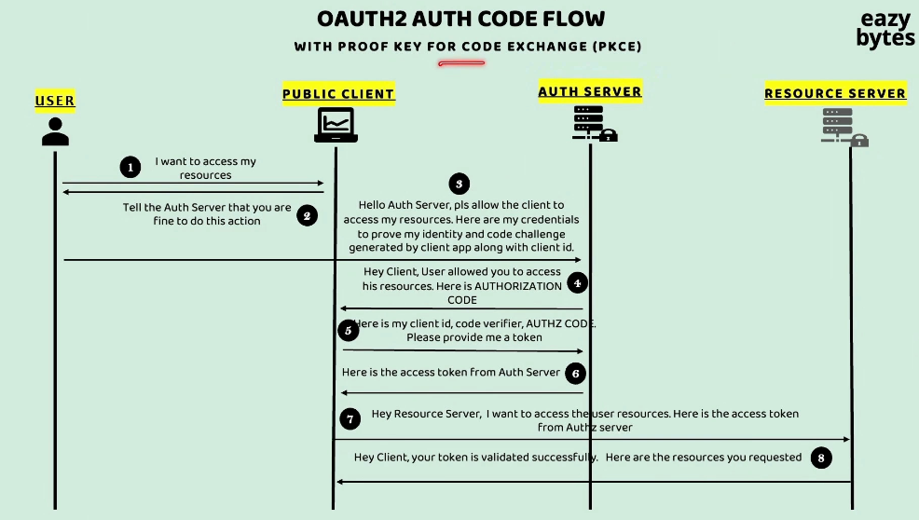

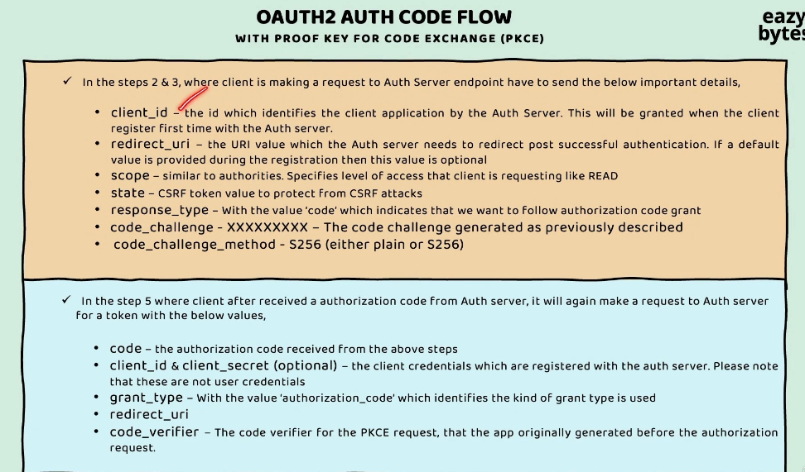

This time, sending the client secret is completely optional because the client application is a public-facing client and that's why it is trying to implement the PKCE flow with the help of this code_challenge and code_verifier.

It is also possible to use the PKCE flow inside non-public clients as well.

Though your client application should be able to store client secret securely,

but still some applications they also try to add PKCE flow as well along with the client secret. They're going to do this for better security.

**So whatever code_challenge and code_verifier that are going to be generated by the client application, they're going to be unique for each and every authentication flow**

**that they're going to trigger, whereas the client secret is always going to be**

**the same value for any number of authentication flows.**

Since PKCE is a more secure approach, these days the recommendation is to use the PKCE flow, regardless whether your client application is a public client or a non-public client.

Demo

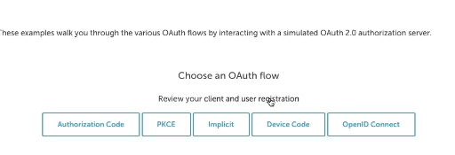 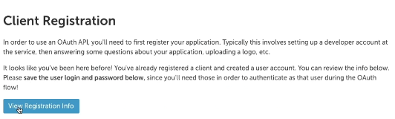

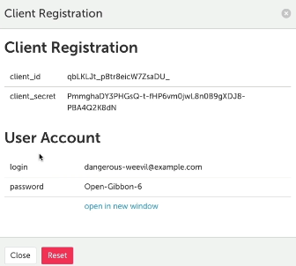 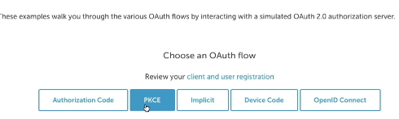

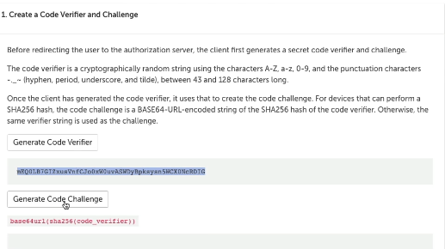

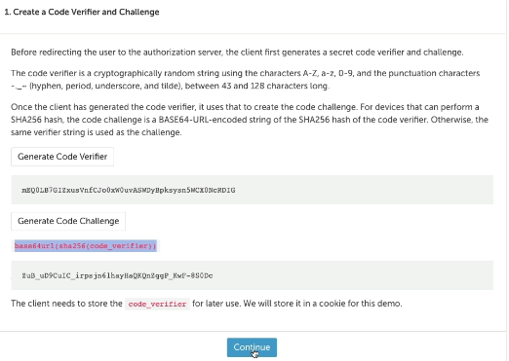

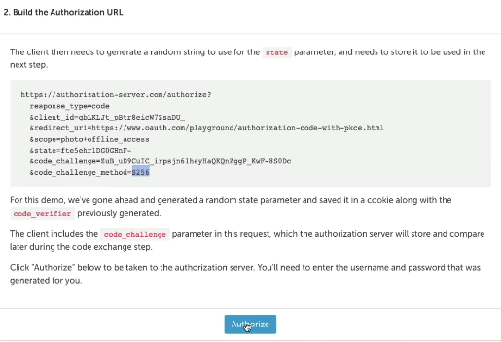

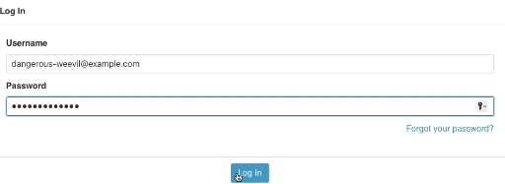

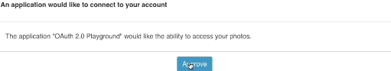

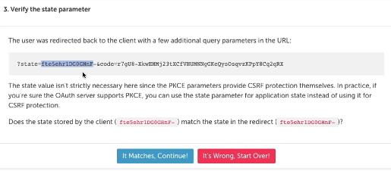

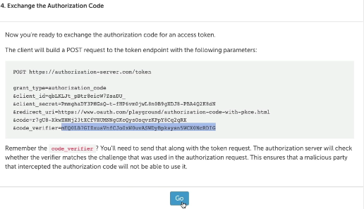

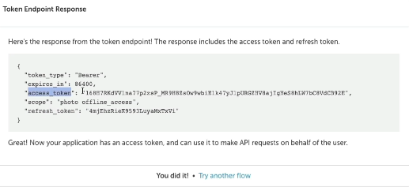

Deep dive of password grant type flow in OAUTH2

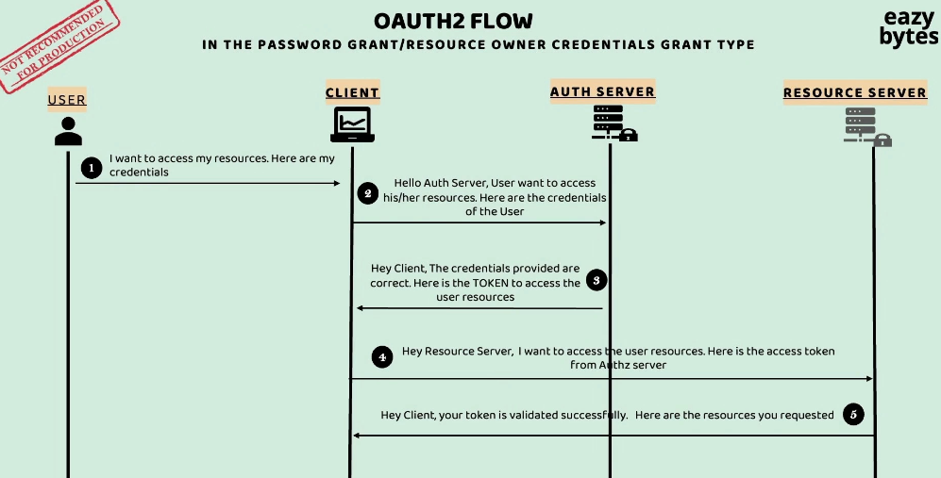

If you try to understand this flow, it's very similar to authorization code Grant Type Flow except with the small change.

But inside this flow, the client application itself is going to have their own login page where they are going to ask the end user credentials that he's maintaining

inside the AUTH server.

So once the end user credentials are accepted by this client application, it is going to make a request to the AUTH server with the details of user credentials, client credentials.

So both the client credentials and the end user credentials, it is going to send as part

of the request to the AUTH server. If all the credentials are valid as part of the step three, the access token is directly going to be issued to the client application.

but the drawback of this flow is the end user has to believe the client application and provide his own credentials. So there is a very good chance that this client application may misuse the end user credentials.

but still you will see some organizations using this Grant Type Flow.

The reason is this flow is very simple to follow, but whenever someone is following this flow, they'll make sure this client application and this AUTH server, Resource Server, they all belongs to the same organization.

So in this kind of setup, there is no chance that this client application can misuse the credentials of the end user because both client and AUTH server belongs to the same organization or the same project.

In this kind of environment it is acceptable but still we should not use it.

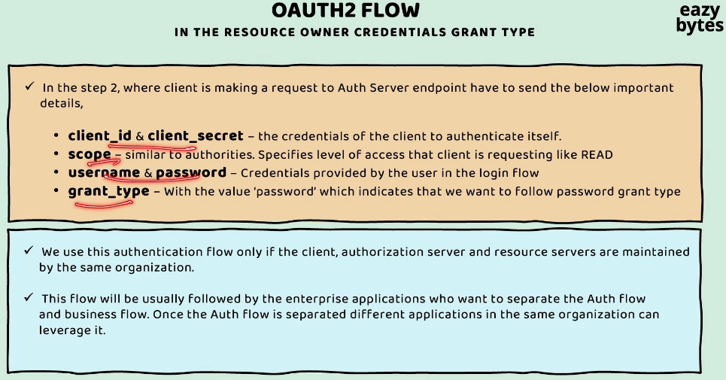

Deep dive of client credentials grant type flow in OAUTH2

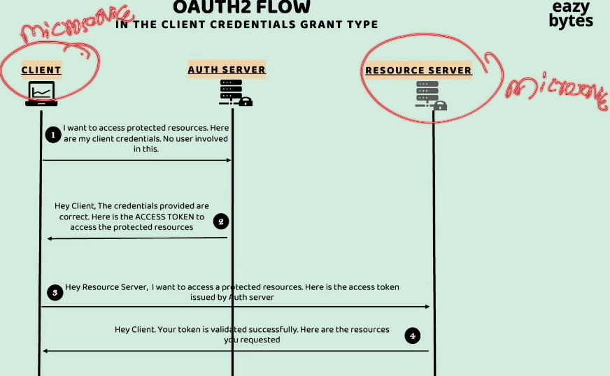

This the most commonly used grant type flow inside the microservices environment.

We need to use this grant type flow when now there is no end user is involved and when our two backend applications are two different APIs that are trying

to communicate with each other.

So this Resource Server can be a microservice and this client also can be another microservice, or some other backend application or backend API who are trying to talk with each other. But instead of directly allowing them to talk with each other, we are going to enforce security with the help of Client Credentials Grant Type Flow.

In the very first step, the client is going to approach the auth server to provide an access token and inside the request it is also going to mention its client credentials

and since there is no user involved inside this, it's not going to share any end user-related details.

If the client credentials are valid, the auth server, it is going to issue an access token to the client. Now my client, which can be a microservice it can invoke another microservice.

In the step three, it is going to invoke the Resource Server where the resources

that it is trying to fetch are present. Inside these third request is going to send

the access token as well, along with the other request details.

If the access token is valid, the Resource Server is going to reply

with the proper successful response.

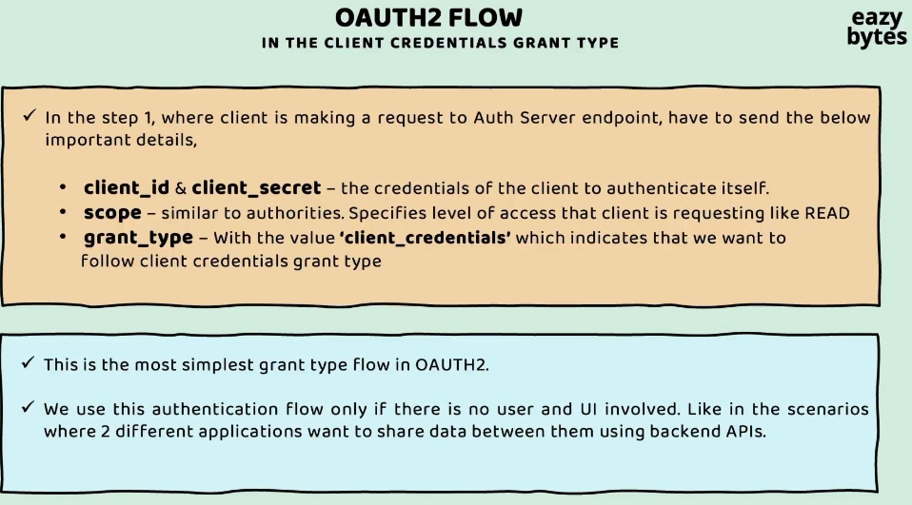

Deep dive of refresh token grant type flow in OAUTH2

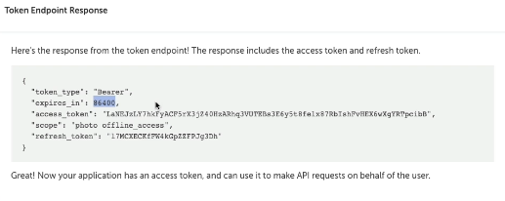

Using this refresh_token, we can use Refresh Grant Type flow.

The purpose of Refresh Grant Type flow is very simple.

Whatever access_token that is going to be issued by the auth server

to the client application, it is going to have some expiration time.

In this scenario, the access_token, it is going to expire in 86,400 second,

which is equal to 24 hours. With this access_token, think of a scenario where an end user initiated the login or authentication process today.

And behind the scenes, the client application receives the access_token, refresh_token and it store all the details on the user browser.

The user will be able to use a client application for up to 24 hours. After 24 hours, maybe after two days or three days, if the end user come back and try to access the same resource inside the client application, this time the client application should not initiate the authentication process again from scratch by redirecting the end user to the login page of the auth server.

It is not going to work that way because it is going to be super inconvenient

for the end user to enter the credentials every time he visits an website.

Take an example of Stack Overflow or Amazon or Facebook.

Do you remember when you entered your credentials inside this website?

You are going to enter only once. And with that, you'll be able to use that website forever inside your system or laptop.

Only in the scenarios where you have cleared your browser cache or you deleted the cookies inside your browser, in such scenarios only, these website, they will ask you to re-authenticate by entering your credentials.

Many times it happens to us, we forget our original credentials on Facebook, Amazon, or any other website. The reason is very simple.

We entered these credentials only once in a lifetime. And if you end up using the same browser, same computer, you never have to enter the credentials again and again. And with that, there is a very good chance that you will end up forgetting your credentials.

**So how this magic is happening is behind the scenes, whenever the access_token is expired, the client application, it is going to leverage the refresh_token and initiate the Refresh Grant Type flow.**

Inside this Refresh Grant Type flow, whenever a client application gives an refresh_token to the auth server.

It is going to give a new access_token to the client application. Using this new access_token, the client application, as usual, can browse the resources inside the website or inside the web application.

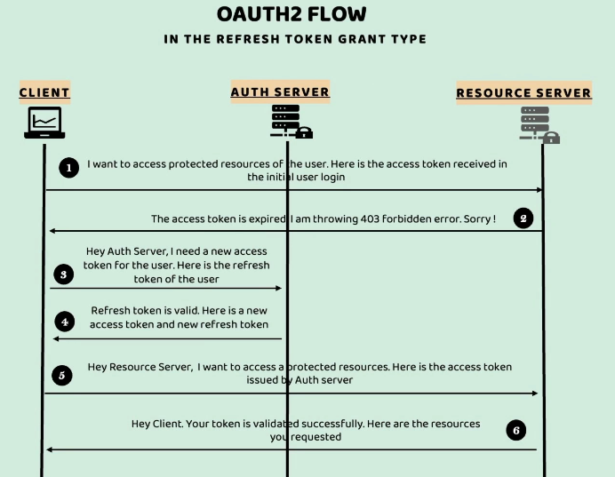

The Refresh Token Grant Type flow, it is only going to be initiated by the client application behind the scenes without involving the end user. That's why here we have only three components, Client, Auth Server and Resource Server.

The end user will only be involved in the scenarios where he has to enter his credentials during the initial authentication process.

So now my client application, it will reach out to the auth server saying that, "Hey, auth server my access_token is expired, I want a new access_token.

And here is the refresh_token that you have issued in the initial authentication process."

**If the refresh_token is valid, the auth server, it is going to issue a new access_token**

**and new refresh_token.**

**We also have an option of using the same refresh_token always, but it is advisable to rotate the refresh_token as well where now these Refresh Token Grant Type flow**

**is being invoked.**

Now using the access_token that it has resolved inside the step four,

my client application, it is going to make a request to the Resource Server.

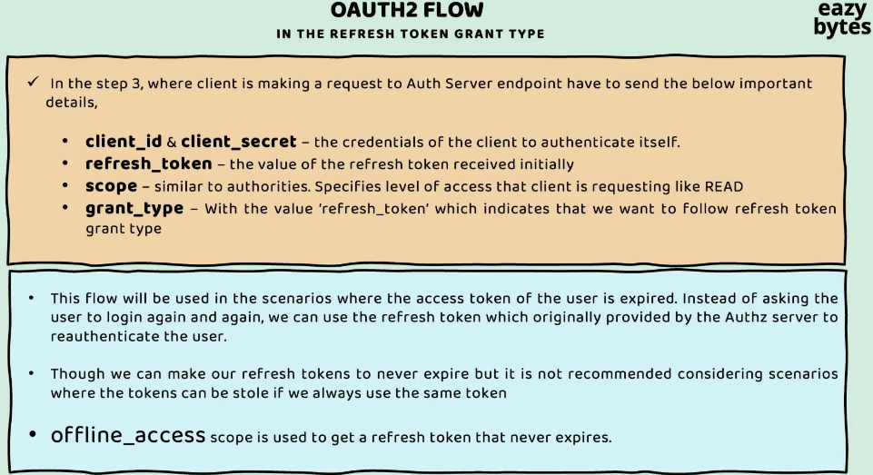

"Why can't we make our refresh_toke

**So under the scope, if you send this value, which is offline_access, you are going to get a refresh_token that never expires.**

But don't use these for real production applications and for critical applications.

This may work for some low critical applications like blog websites or Stack Overflow website.

How resource server validates the tokens issued by Auth server

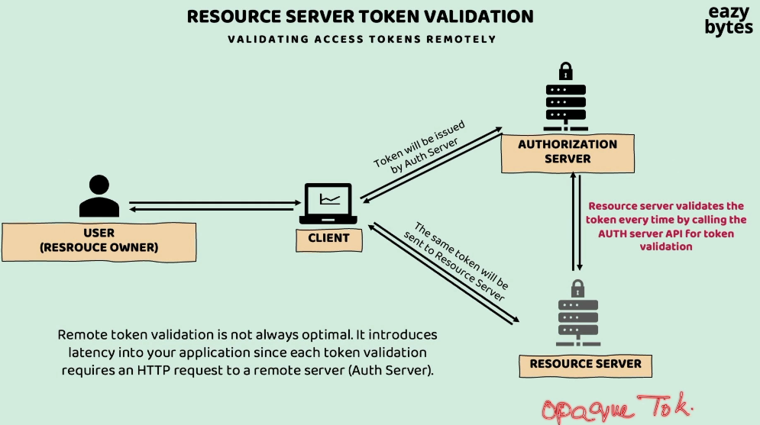

The very first approach is validating the access tokens remotely.

Inside this approach, whenever the Resource Server, it receives an access token,

it will simply send that access token to the Authorization Server to check if the access token is valid or not.

So inside this approach, always, the Resource Server is going to depend on the Authorization Server by making a API invocation on the auth server to identify if a token is valid or not.

Usually, the auth servers, they're going to expose an API with the name /**introspect**.

Using these /introspect API, the Resource Servers, they can identify whether a given token is valid or not.

But this approach, it has some drawbacks.

The drawback is it always going to introduce latency inside your application,

thus bringing some performance issues.

Before responding to each of the requests, it has to make a network call to the auth server, and if your auth server is taking 200 milliseconds time to respond,

then, obviously, these 200 milliseconds is going to be added to your overall request to network latency.

That's why most of the organizations, they don't use this approach, but this approach is going to be useful for the organizations where they have some super critical data.

Such organizations. they can follow this approach.

**So when an organization want to use this approach, then they need to make sure**

**that the format of their access token is of type opaque token.**

There are 2 types of tokens we have, JWT token and Opaque token.

JWT tokens are self-contained, whereas Opaque tokens, they're just some random String values with no inherent meaning.

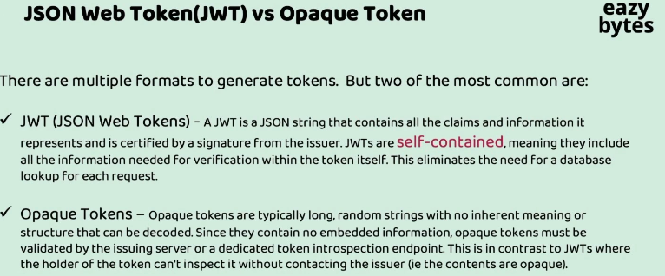

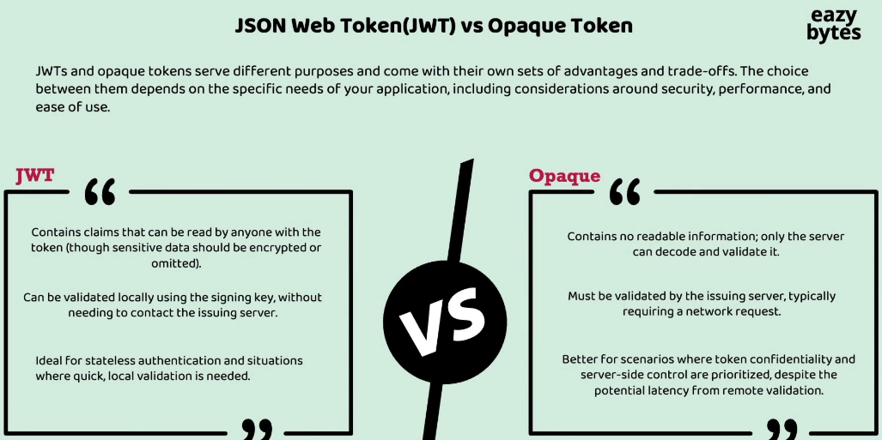

So inside the first approach, always, the token has to be in a Opaque format

so that the Resource Server can send this Opaque token to the auth server to know more details about the end user and to know whether the Opaque token is valid or not.

The next approach, which is the most commonly used approach, is validating the access tokens locally. In this scenario, the Resource Server, it is going to validate the token locally without making a network call to the Authorization Server.

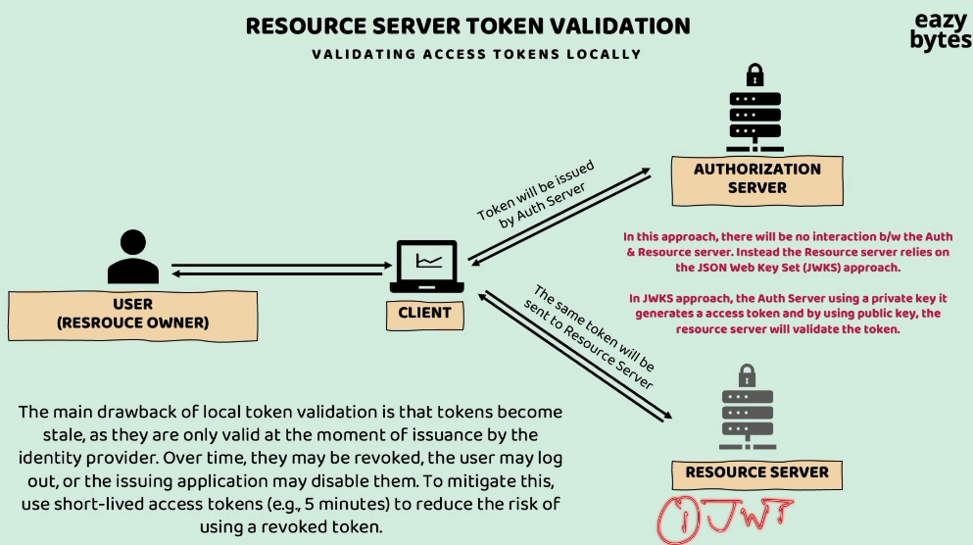

To make this approach work, we need to follow two rules.

The very first rule is the token format should be of type JWT. Since JWTs, they're going to have digital signature to validate locally, the same format we need to use in this approach.

Since JWTs, they're going to have digital signature to validate locally, the same format we need to use in this approach.

In the previous section, while we were discussing about the JWT tokens, we discussed about a scenario where JWT tokens that are going to be validated by using a secret value, but inside the OAuth 2 flow, the secret value is not going to be used.

Instead, **JWKS approach** is going to be followed. So as part of this approach, the Authorization Server is going to have a private key. Using this private key, it can issue that tokens.

Corresponding to this private key, there will be a public key which the Resource Server has to download during the startup of the application.

Using this public key, the Resource Server can validate if the given digital signature of a token is valid or not. So here, there is no secret involved.

The auth server will make sure that it is not losing this private key, and this public key can be given to any number of Resource Servers to validate that token by checking that digital signature with the help of this public key.

**During the start of this Resource Server, it is going to make a request to the auth server to download the public key. So once this public key is downloaded,**

**the same key can be used by the Resource Server locally to validate the tokens issued by the auth server.**

So this approach has an advantage, which is it is not going to depend on the auth server to validate the tokens. With that, you're not going to have any performance

or latency issues.

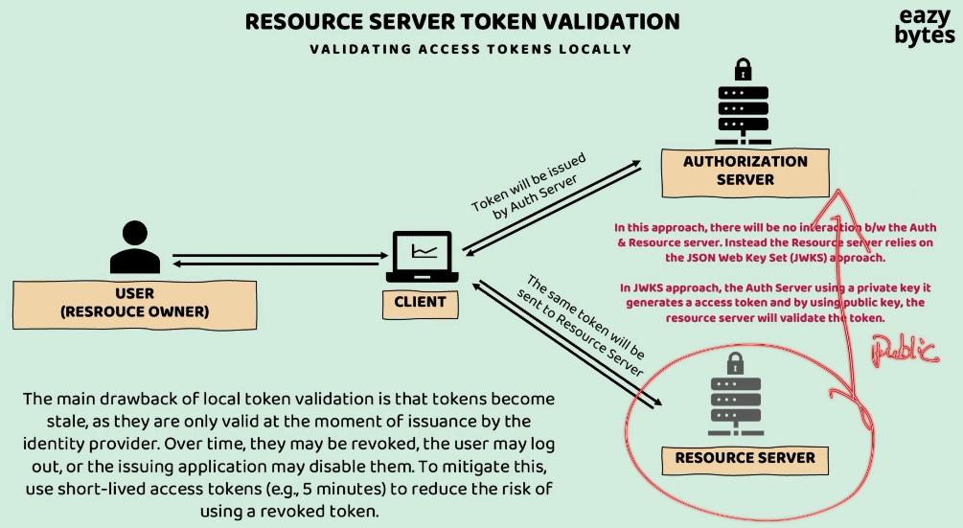

But there is a drawback with this approach. Think like the auth server issued an access token with the 24 hours expiration time.

So my Resource Server will keep accepting the token for 24 hours.

For some reason, within these 24 hours, if the token is stolen or if the token want to be revoked, we can't do that because there is no way for the Authorization Server

to communicate with the Resource Server to invalidate these token value within 24 hours.

So that's why to mitigate these drawback or issue, usually, organizations which have some critical applications, they're going to issue the access tokens with a short life, for example, with a five minutes time. So this is going to reduce the risk

of using a revoked token.

Introduction to OpenID Connect

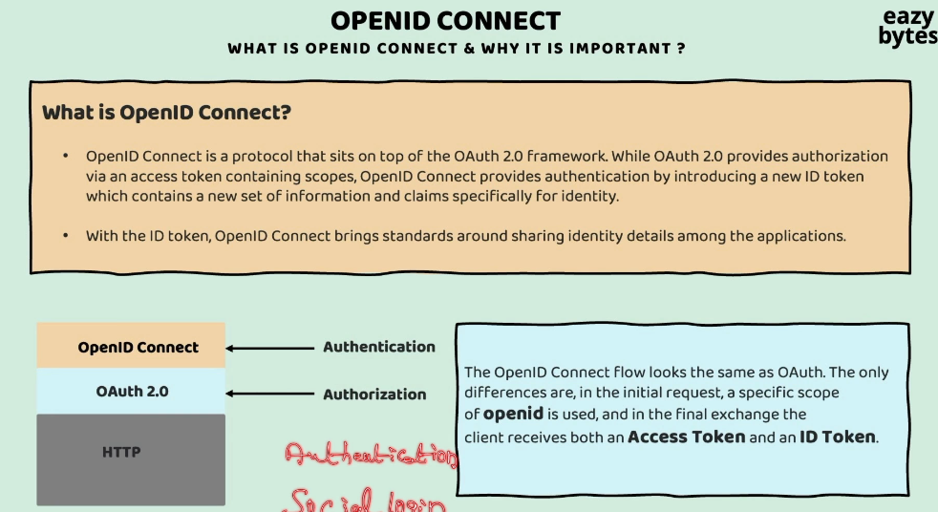

Now, let's try to understand what is the need to build an extra layer on top of the OAuth 2.0 frameworkwhen OAuth 2.0 framework is able to solve all our security problems.

So, let's try to understand the same.

Initially, when the OAuth 2.0 framework introduced, it is introduced by considering authorization into picture. So, with the help of OAuth 2.0, what we're trying to do,

an end user is going to give an authorization access to a third party application or a two different application to access his or her resource on behalf of himself or herself.

So, that's a original intention of authorization.

That's why inside the authorization standards or specifications, we have concepts like scopes. Using these scopes only, we can control what kind of access that we can give to the third party application.

Apart from scope, we have access token.

Inside this access token only, all the scope details are also going to be maintained by the auth work. The same is going to be used by the client application.

Though the intention of introducing the OAuth 2.0 framework is for authorization, but inside the industry, what happened is, many of the website,

especially the public-facing clients,

blogs, single-page applications,

they all started using the OAuth 2.0 framework

for the authentication of the end user.

So, how these authentication is possible?

With the help of social login.

We saw inside the Stack Overflow scenarios,

Slack website scenario,

there are options for the end user to sign up

or to sign in into their website

with the help of Google,

LinkedIn, Facebook, GitHub, Twitter.

So, by leveraging most

of the social applications auth servers,

public-facing websites,

they started implementing the OAuth 2.0 framework

even for the authentication as well.

But when they started OAuth 2.0 for authentication,

they end up having a problem

which is whenever the OAuth 2.0 framework

is being used by an application,

it is only going to have the access token.

Inside this access token,

we are going to have details around scopes

and in some scenarios,

it is also going to have some user-related information.

In certain scenarios, the website,

by looking at this access token,

they will not be able to understand

to whom these access token belongs

or to which identity this access token belongs.

And to solve this problem, most of the organizations,

they used to have some workarounds

to identify to which user this access token belongs.

And to identify more details about the end user,

they used to follow different workaround.

And since everyone is going to have their own workarounds,

there is no uniform approach inside the OAuth 2.0 framework

in sharing the user details or identity details.

So, in other words, user we can call it as identity.

So, since there is no uniform way

of sharing the user details inside the OAuth 2.0 framework,

a new small wrapper is built on top of this OAuth 2.0.

This wrapper is called OpenID Connect.

So, OpenID Connect built by focusing the authentication.

So, during the authentication, what is going to happen,

we are going to focus

on the end user to identify who is the end user.

With the OpenID Connect, there is more standard way

or there is more uniform way came into picture

to know more details about the end user

who is right now involved

inside the authentication or authorization flow.

So, whenever we are using OpenID Connect,

all the grant type flows,

they are going to work very similar

to whatever we have discussed previously.

But the only difference

is whenever you want to enable this OpenID Connect,

instead of only the OAuth 2.0,

you just need to add the scopes

related to OpenID inside your request.

Inside your request,

if you mention the scope as OpenID,

with that, the OpenID Connect is going to be enabled.

And as a response your authorization server,

it is going to issue two types of tokens.

First one is access token and the other one is ID token.

Off course there is third token

which is refresh token as well.

Let's not worry about the refresh token.

Refresh token purposes are completely different.

So, this access token

is always going to be used for authorization,

because inside this access token,

we'll have details around the scopes.

Whereas this ID token

will have the user details like what is the username,

what is his email,

what is his address details, what is his email address?

So, all such details,

they're going to come inside this ID token.

So, anytime client application has a question

around to which end user this access token belongs,

they can directly refer to these ID token for the details.

This way, the drawbacks of OAuth 2.0

are addressed with the help of OpenID Connect.

So, with the introduction of OpenID Connect,

a new concept came into picture, which is IAM.

So, identity and access management.

So, the OpenID Connect,

it is going to help you to identify the end user

and it is going to help you

in the process of authentication,

whereas the OAuth standard or framework

is going to help you during the access management

and during the authorization process.

Since we are trying to club both of them,

a new concept with the name IAM came into picture.

So, if you go to any website where they're trying

to provide the capabilities of auth server,

for example, Keycloak, Okta, AWS Cognito.

So, all these products,

they're going to highlight about this concept

which is identity and access management,

which means behind the scenes,

they're using both this OpenID Connect

and OAuth 2.0 inside the auth server

that they're going to provide.

In short form, if anyone ask you

to explain about the OpenID Connect in a simple words,

you can mention these three points to them.

The very first point is with the help of OpenID Connect,

in other words, we can also call it as OIDC.

So, OpenID Connect.

So, this the short form of OpenID Connect.

So, this OIDC standardizes the scopes

to OpenID profile, email, and address.

So, these are the scopes

that got introduced as part of OpenID.

Whenever someone is trying to mention these scope details

inside the request,

they're going to get all the user-related information

in the form of ID Token.

And the second point is like I said,

whenever someone is using OpenID Connect

in their communication,

they're going to get an ID token on top of access token.

This ID token also is going to use the format of JWT tokens.

And the last and important point is,

any auth server that has been implemented

with the help of Open ID Connect,

it is also going to expose an REST API

with the name userinfo.

At any point of time,

if my client application is looking for more details

of an end user,

it can get those details by invoking these REST API.

So, this is also another standard approach

instead of relying on the ID token, the client application,

they can always invoke these API to know more details

about the identity or about the end user.

